Advanced Engineering Mathematics, by Erwin Kreyszig 10th. Ed.

**Problem Set 9.4**

No.1



y

c x

No.2



y

c x

No.3

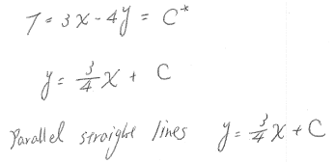

No.4



No.5

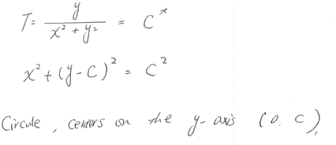

No.6

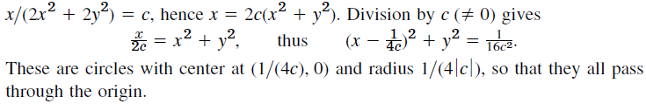

No.7

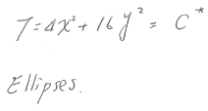

No.8

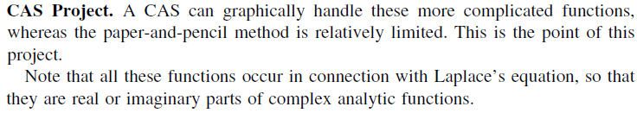

No.9

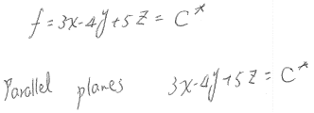

No.10

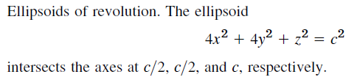

No.11

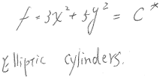

No.12



No.13

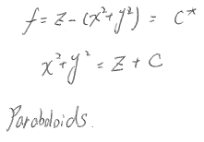

No.14



No.15

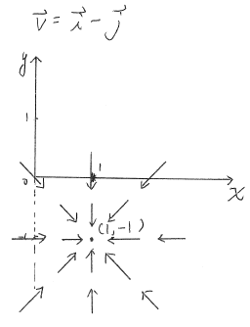

No.16

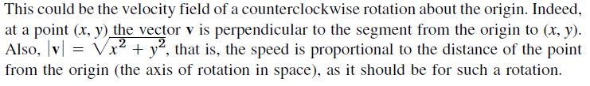

No.17

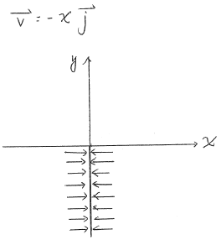

No.18



No.19

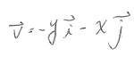

No.20



No.21

問答或證明題，不解

No.22

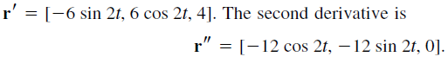

No.23

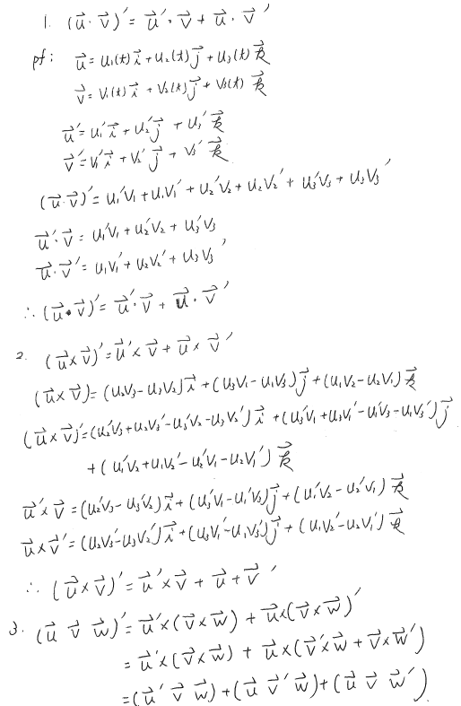

No.24

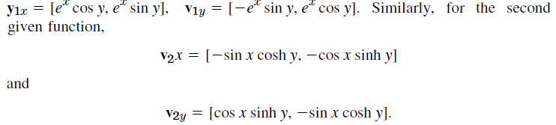

No.25

